The Foutan Circuit board is a great fun way to introduce series, parallel and comples circuits. The Foutan Circuit Board helps students as they predict the switch positions on the Foutan Circuit Board would be needed to create the different circuits and consequently light the correct bulbs. Over thirty-five different circuit combinations are possible. Have your students bring sun glasses because some of the circuits may be very bright!

The Foutan Circuit Board

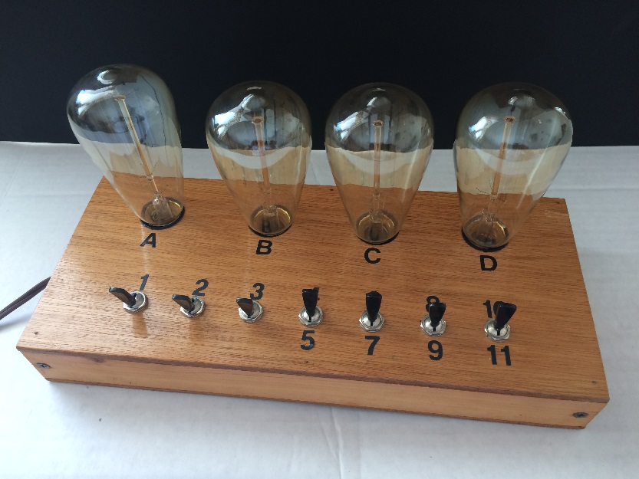

The Foutan Circuit Schematic

D
A
B
C
2
3
5
9
8
7
6
1
11
4
10

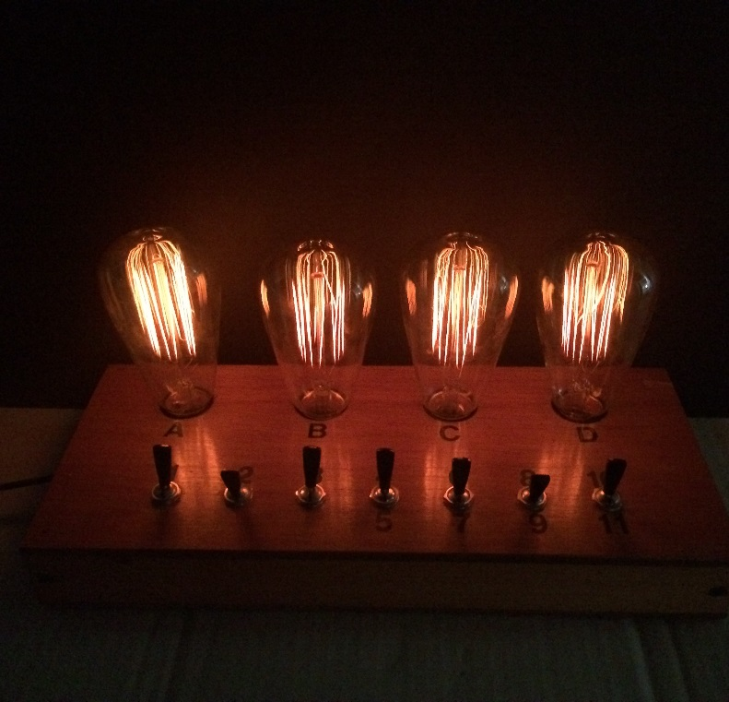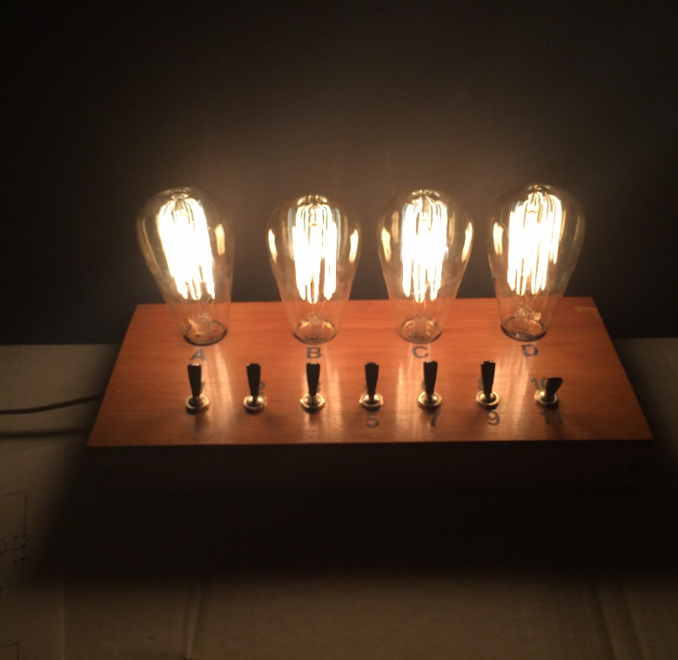
A, B, C, and D all in series
A, B, C, and D all parallel

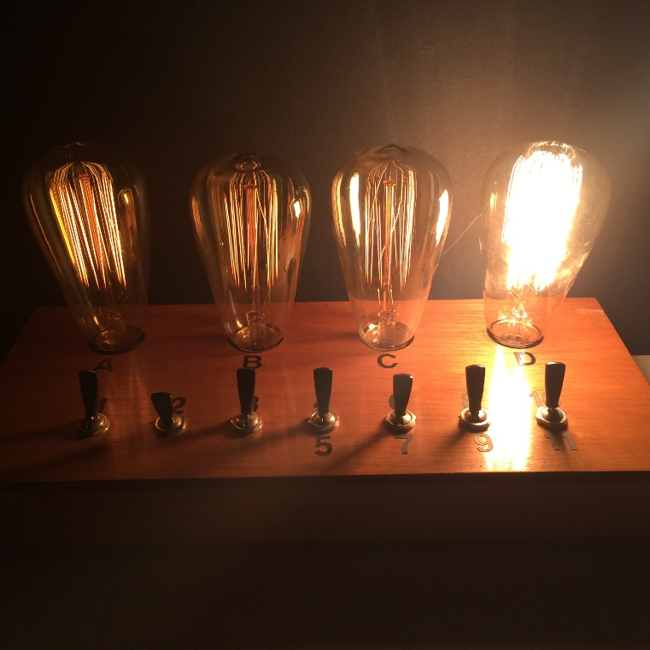
A, B, C in series, D parallel with A, B,C

